**Resume**

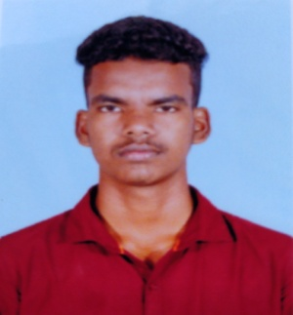

Kabilan S

Mobile No: 8825856493

Mail Id: [Kabilansenthil07@gmail.com](mailto:Kabilansenthil07@gmail.com)

**Objective**

I wish to obtain a position in year esteemed organization. I am looking for a good career growth opportunity, Where my talent and knowledge could best subjected and utilized for the benefit of the organization and myself also.

**Education**

**B.Tech (IT)** -The University College of Engineering (Bit Campus) 2021-2025-Trichy

**HSC-**with 88.3% at Government higher secondary school, Veppur in the year2021.

**SSLC-** With 83.6% at Government higher secondary school, Veppur in the year2019.

**Skills**

* Programming
* Communication Skill
* Web Designing
* UI/ UX Designing
* Team Work

**Software**

* python
* C language
* Java

**Languages**

* Tamil-R,W,S
* English- R,W,S

**Personal Details**

Name : Kabilan s

Father Name : Senthilkumar k

Gender : male

DOB : 18-12-2004

Marital Status : un-married

Religion : Hindu

Nationality : Indian

Address : 4/224,Perumal Kovil Street,Kallai,Olaipadi(post),Kunnam(tk),

Perambalur(Dt)-621717.

**Declaration**

The information stated above is true to the best of my knowledge and belief.

**Date:**

**Place:**

**Signature**

**(Kabilan S)**